Cynllun y gweithgaredd:

Amcanion Dysgu a chyfarwyddiadau:

- Dysgu termau Celf amrywiol.
- Dysgu sut i ddefnyddio geiriaduron termau yn effeithiol.
- Dwyn gwaith blaenorol i gof (Gwahaniaethol).

Gallwch gysylltu’r dasg hon â gwaith blaenorol drwy ganolbwyntio ar unrhyw un o’r termau isod.

Er mwyn gweld fideo sy’n egluro sut i ddefnyddio’r Termiadur Addysg, sganiwch y cod QR ar waelod y dudalen neu ewch i https://www.youtube.com/watch?v=6z8klxzufx8&t=8s .

Atebion Chwilair:

Ar draws
2) Blue = Bliw
4) Amber = Melyngoch
6) Adhesion =Adlyniad
9) Carver = Cerfiwr
10) Brief = Cryno
I lawr
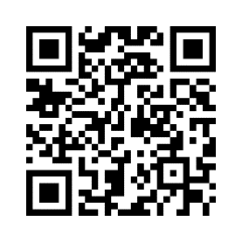
1) Bristle = Blewyn
3) Abrasion = Sgrafelliad
5) Blue = Glas
7) Set = Setio
8) Cloth = Brethyn

Activity plan:

Learning outcomes and instructions:

- Learn various new Art terms.
- Learn how to use a terms dictionary effectively.
- Recall previous work (Differential).

You can link this task to previous work by concentrating on any of the terms in the list below.

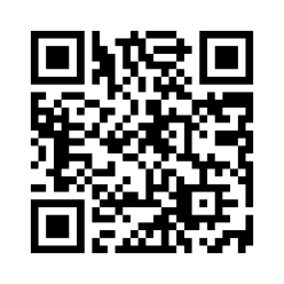
To watch a video that explains how to use the Termiadur Addysg, scan the QR code at the bottom of the screen or go to https://www.youtube.com/watch?v=BzbrqUr5Hvk&t=2s

Crossword Ansewrs:

Across
2) Blue = Bliw
4) Amber = Melyngoch
6) Adhesion =Adlyniad
9) Carver = Cerfiwr
10) Brief = Cryno
Down
1) Bristle = Blewyn
3) Abrasion = Sgrafelliad
5) Blue = Glas
7) Set = Setio
8) Cloth = Brethyn

