Termau Celf / Art Terms

Defnyddiwch Y Termiadur Addysg (www.termiaduraddysg.cymru) er mwyn canfod y termau Cymraeg cyfatebol a chwblhau’r chwilair. Cofiwch ystyried maes pwnc y term a’i ddadamwysydd! Gwnewch yn sicr eich bod wedi gwylio’r fideo cyn parhau (sganiwch y cod QR ar waelod y dudalen!).
Use the Termiadur Addysg (www.termiaduraddysg.cymru) to find the corresponding Welsh terms to complete the crossword. Remember to consider the subject field and the disambiguator! Make sure that you have watched the video before continuing (scan the QR code at the bottom of the page!).
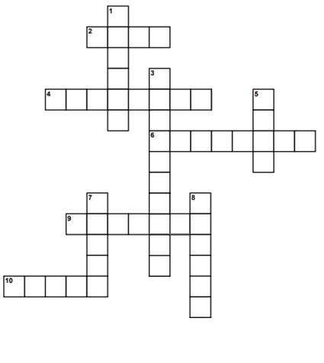

Ar draws / Across
2) Blue
4) Amber
6) Adhesion
9) Carver
10) Brief
I lawr / Down
1) Bristle
3) Abrasion
5) Blue
7) Set
8) Cloth

Pa rai o’r termau uchod sy’n gysylltiedig â’r gwaith rydych chi wedi ei wneud yn y dosbarth? Eglurwch eich ateb.

Which of the above terms is linked to the work you have done in class? Explain your answer.

……………………………………………………………………………………………………………………………………………………………………………………….

……………………………………………………………………………………………………………………………………………………………………………………….

……………………………………………………………………………………………………………………………………………………………………………………….

……………………………………………………………………………………………………………………………………………………………………………………….

……………………………………………………………………………………………………………………………………………………………………………………….

……………………………………………………………………………………………………………………………………………………………………………………….

Ymchwiliwch i rai o dermau’r chwilair sy’n anghyfarwydd i chi. Nodwch tair ffaith am un ohonynt.
Research some of the terms in the crossword that are new to you. Give three facts about one of them.

……………………………………………………………………………………………………………………………………………………………………………………….

……………………………………………………………………………………………………………………………………………………………………………………….

……………………………………………………………………………………………………………………………………………………………………………………….

……………………………………………………………………………………………………………………………………………………………………………………….

