Art Terms

Use the Termiadur Addysg (www.termiaduraddysg.cymru) to find the Corresponding Welsh terms to complete the crossword. Remember to consider the subject field and the disambiguator! Make sure that you have watched the video before continuing (scan the QR code at the bottom of the page!).
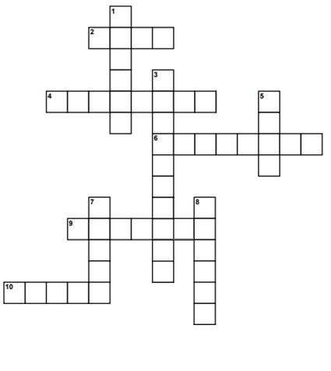

Across
2) Blue
4) Amber
6) Adhesion
9) Carver
10) Brief
Down
1) Bristle
3) Abrasion
5) Blue
7) Set
8) Cloth

Which of the above terms is linked to the work you have done in class? Explain your answer.

……………………………………………………………………………………………………………………………………………………………………………………….

……………………………………………………………………………………………………………………………………………………………………………………….

……………………………………………………………………………………………………………………………………………………………………………………….

……………………………………………………………………………………………………………………………………………………………………………………….

……………………………………………………………………………………………………………………………………………………………………………………….

……………………………………………………………………………………………………………………………………………………………………………………….

Research some of the terms in the crossword that are new to you. Give three facts about one of them.

……………………………………………………………………………………………………………………………………………………………………………………….

……………………………………………………………………………………………………………………………………………………………………………………….

……………………………………………………………………………………………………………………………………………………………………………………….

……………………………………………………………………………………………………………………………………………………………………………………….

